

CONSUL Use Guide Versión 0.16

Index of contents

0. Introduction to the CONSUL Use Guide

1. Citizen proposals

2. Voting

3. Collaborative legislation

3.1. Preliminary discussion

3.2. Proposals

3.3. Comments on texts

4. Participatory budgets

5. Debates

6. Advanced processes

6.1. Debates Phase

6.2. Proposal Phase

6.3. Text comment phase

7. Customizable home page

8. Personalized information pages

9. Newsletters and notifications

10. Administration, Moderation, Evaluation, Voting and Management Interfaces

11. Face-to-face participation in the processes

0. Introduction to the CONSUL Use Guide

CONSUL is the software developed by Madrid City Council to facilitate citizen participation. CONSUL enables a direct system of communication with the administration that allows citizens to make proposals for action to be supported by other users, express their decision on particularly significant issues of the institutional action, participate in the process of developing regulations or decide on the destination of part of the institutional budget.

CONSUL makes it possible to carry out all the most relevant participatory processes and to adapt them to the specific needs of each situation. It has been designed in a totally configurable way so that the different processes can be activated or deactivated, and configured in different ways. In this way it can be adapted to any need.

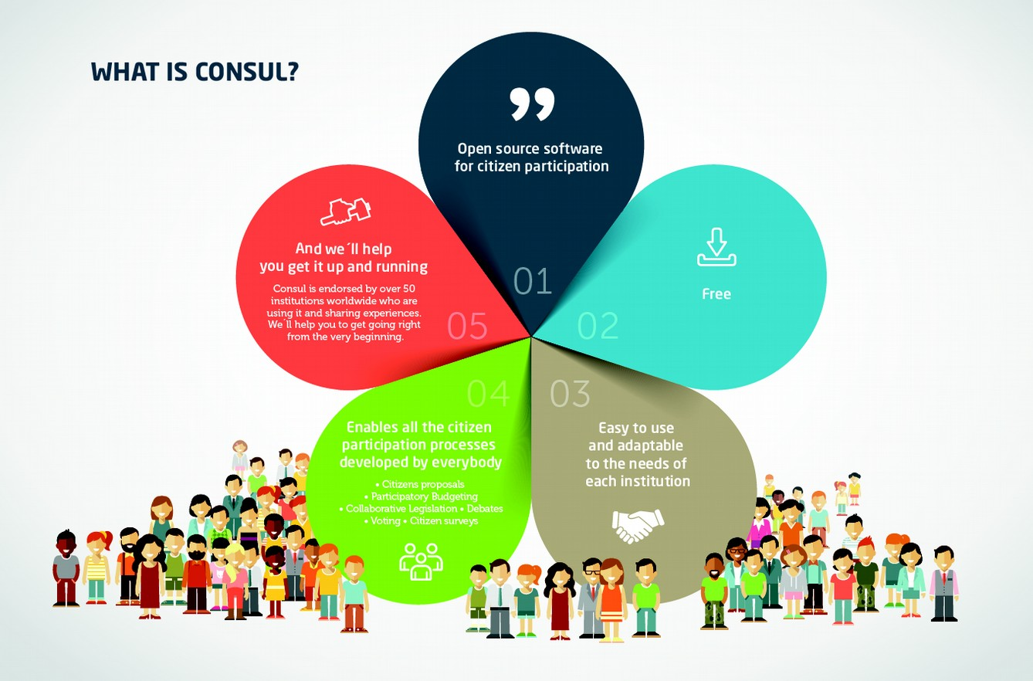

The main participation processes that can be carried out in CONSUL are the following:

- Citizen Proposals. Anyone can make proposals to improve their city. The proposals can gather supports and in case of reaching a certain threshold pass to vote.

- Voting. Voting can be carried out on proposals from both the citizenry and the institution. In addition, they can be directed to the whole territory or only to certain zones.

* Collaborative Legislation. It allows citizens to participate actively in the drafting of legislation and action plans.
* Participatory Budgets. Citizens directly propose and decide how to spend part of the institution's budget. Each person can make proposals and vote on the initiatives of others. The most voted proposals will be carried out.

- Debates. Citizens can open threads of discussion on any topic and create independent spaces where they can debate and give their opinion on a specific topic. Institutional representatives also have verified profiles in order to be able to open the debates they consider appropriate.

- Advanced Processes. The tool makes it possible to design more complex participation processes with different phases of participation that are defined specifically for each process. These phases may include open debates, selection of proposals, proposal and prioritization of measures, comments on texts, etc.

In addition to the advanced process modality, which allows the configuration of customized processes, CONSUL developers from all over the world work together to include any new type of process or modality that is proposed but not contemplated. CONSUL is free software, which implies that developers around the world work together continuously to improve it, and anyone can join that development, or propose changes and new features to be included. You can also use and modify the platform directly without any restrictions. The code is yours and you can do whatever you want with it freely.

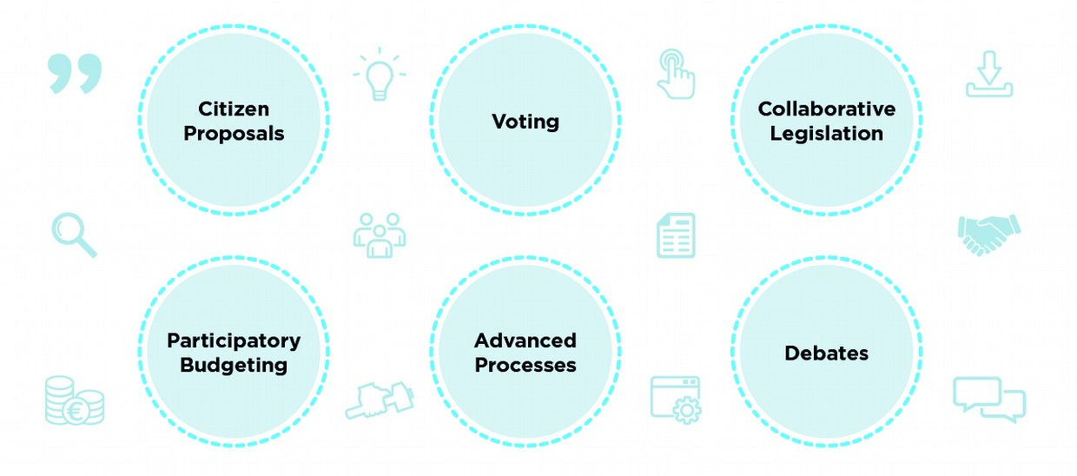

In the following sections we will present concrete examples of participatory processes that can be carried out to better understand what we can do with CONSUL.

1. Citizen proposals

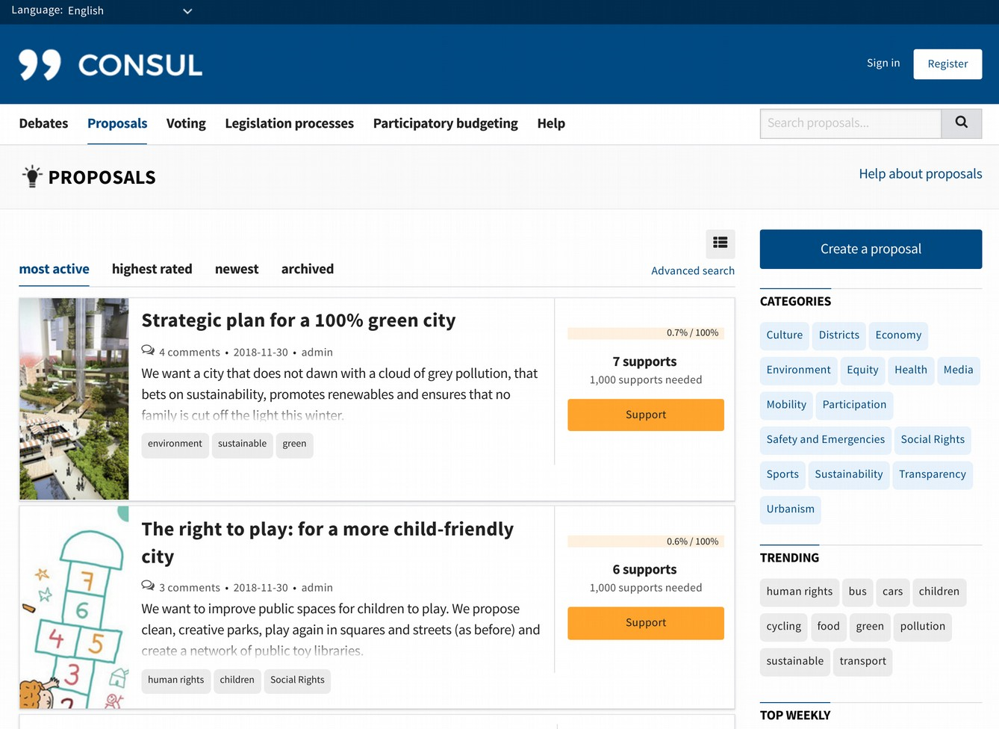

The proposals section allows anyone to submit proposals. These proposals gather supports up to a decided threshold to select the most relevant ones. When they reach this threshold, the proposals can be moved to the voting section, where a vote can be taken for or against the proposal, or directly considered to be carried out.

The list of proposals changes regularly, showing new proposals and also those that generate more interest. It is also possible to sort proposals by other criteria (more supported, more recent, etc.).

Proposals can include tags, images, documentation, videos, location on a map or other relevant information. It also has a comment space where anyone can discuss the proposal, as well as vote on other comments to select the most relevant ones.

The author of the proposal can create notifications, which will be published on the proposal page, in addition to being sent by email to everyone who has supported the proposal. In this way the author can communicate any news about the proposal, or encourage the necessary support to be gathered.

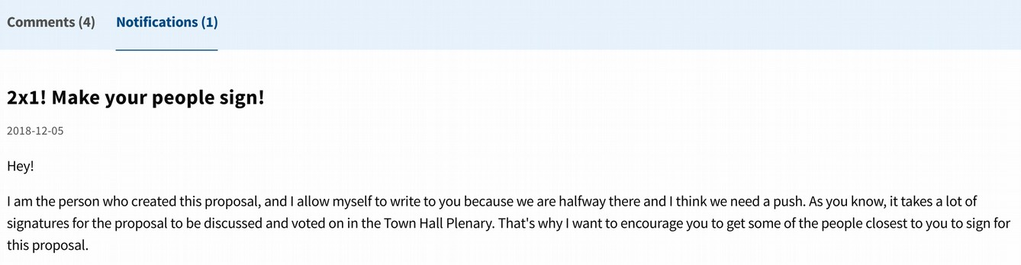

Proposals have a Related Content section, where any user can point to other proposals or similar discussions. This helps to concentrate efforts on similar proposals, and to create communities of users who work together.

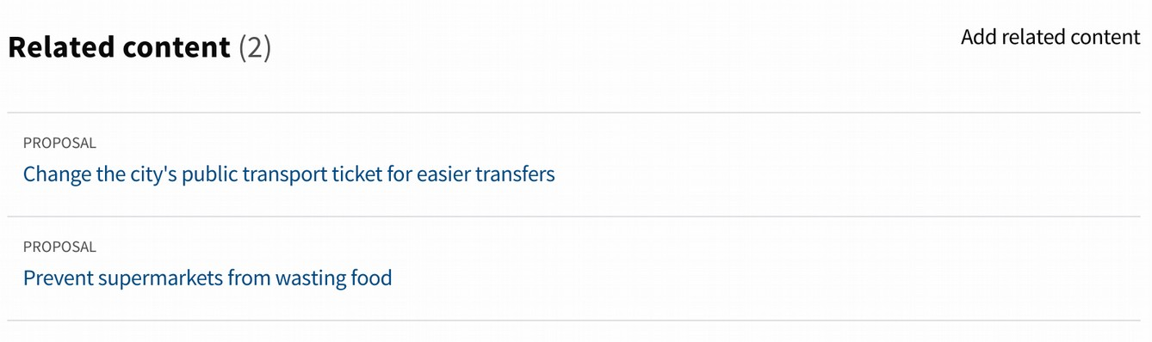

When a proposal is created, a Community space is automatically generated for the proposal.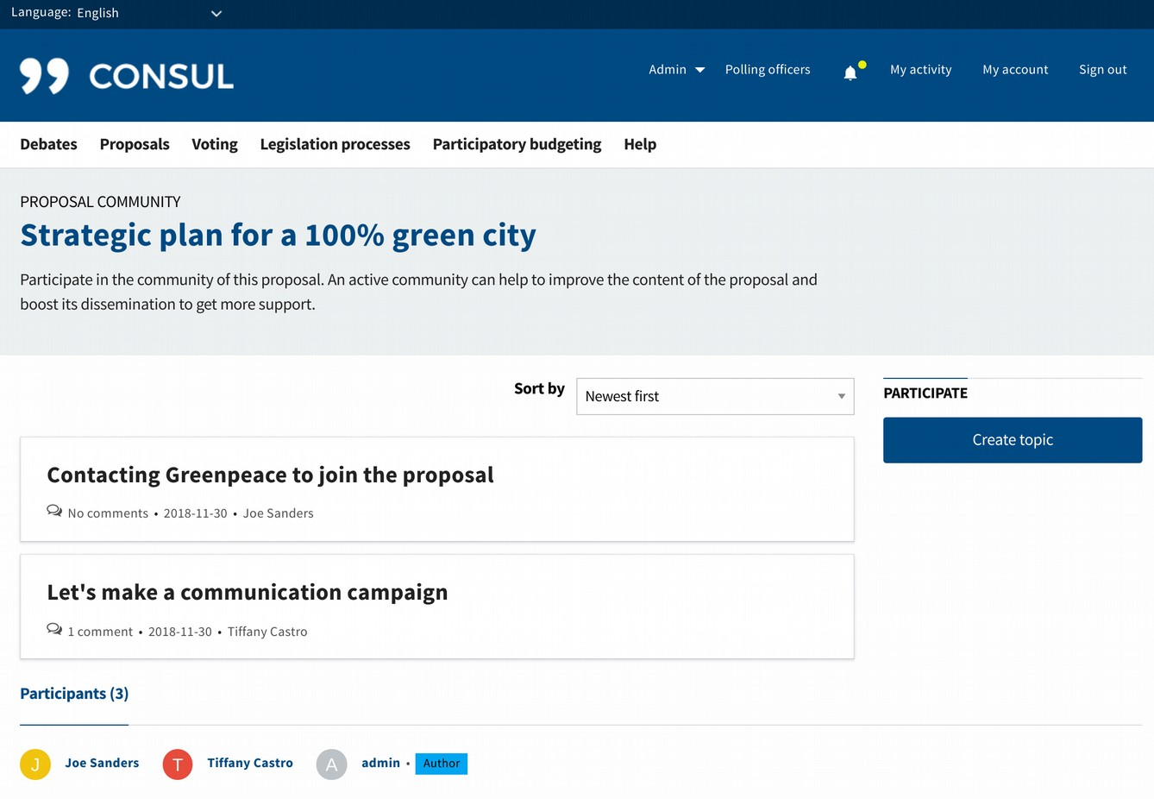

In this space users can open all the debates they want, to work together around the proposal. It is a space designed for users who want to get more involved in the success of the idea.

2. Voting

The voting module allows to vote on citizens proposals, or specific questions that are raised by the institution.

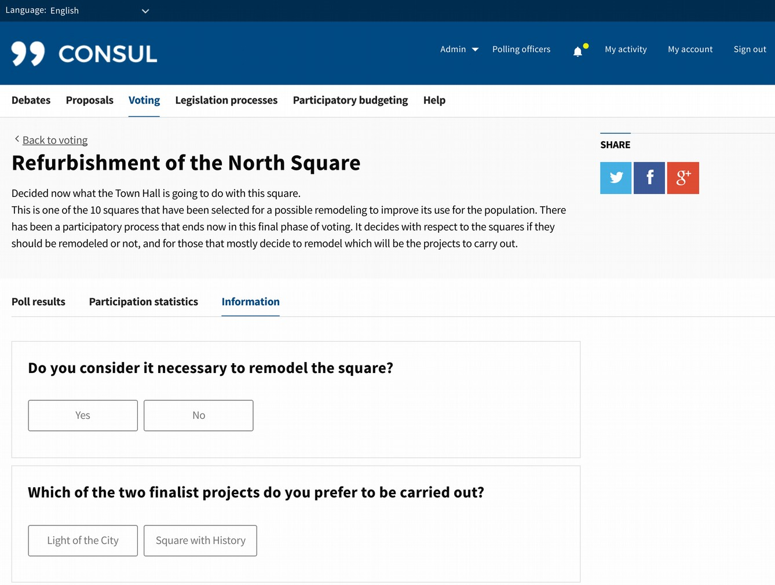

One of the specific questions to be voted on could be, for example, the redevelopment of a square. In this case for example we could include two questions: If you want to remodel the square or not, and which of the finalist projects should be selected in case of remodeling:

Each of the voting options can include images, documentation, videos, etc.

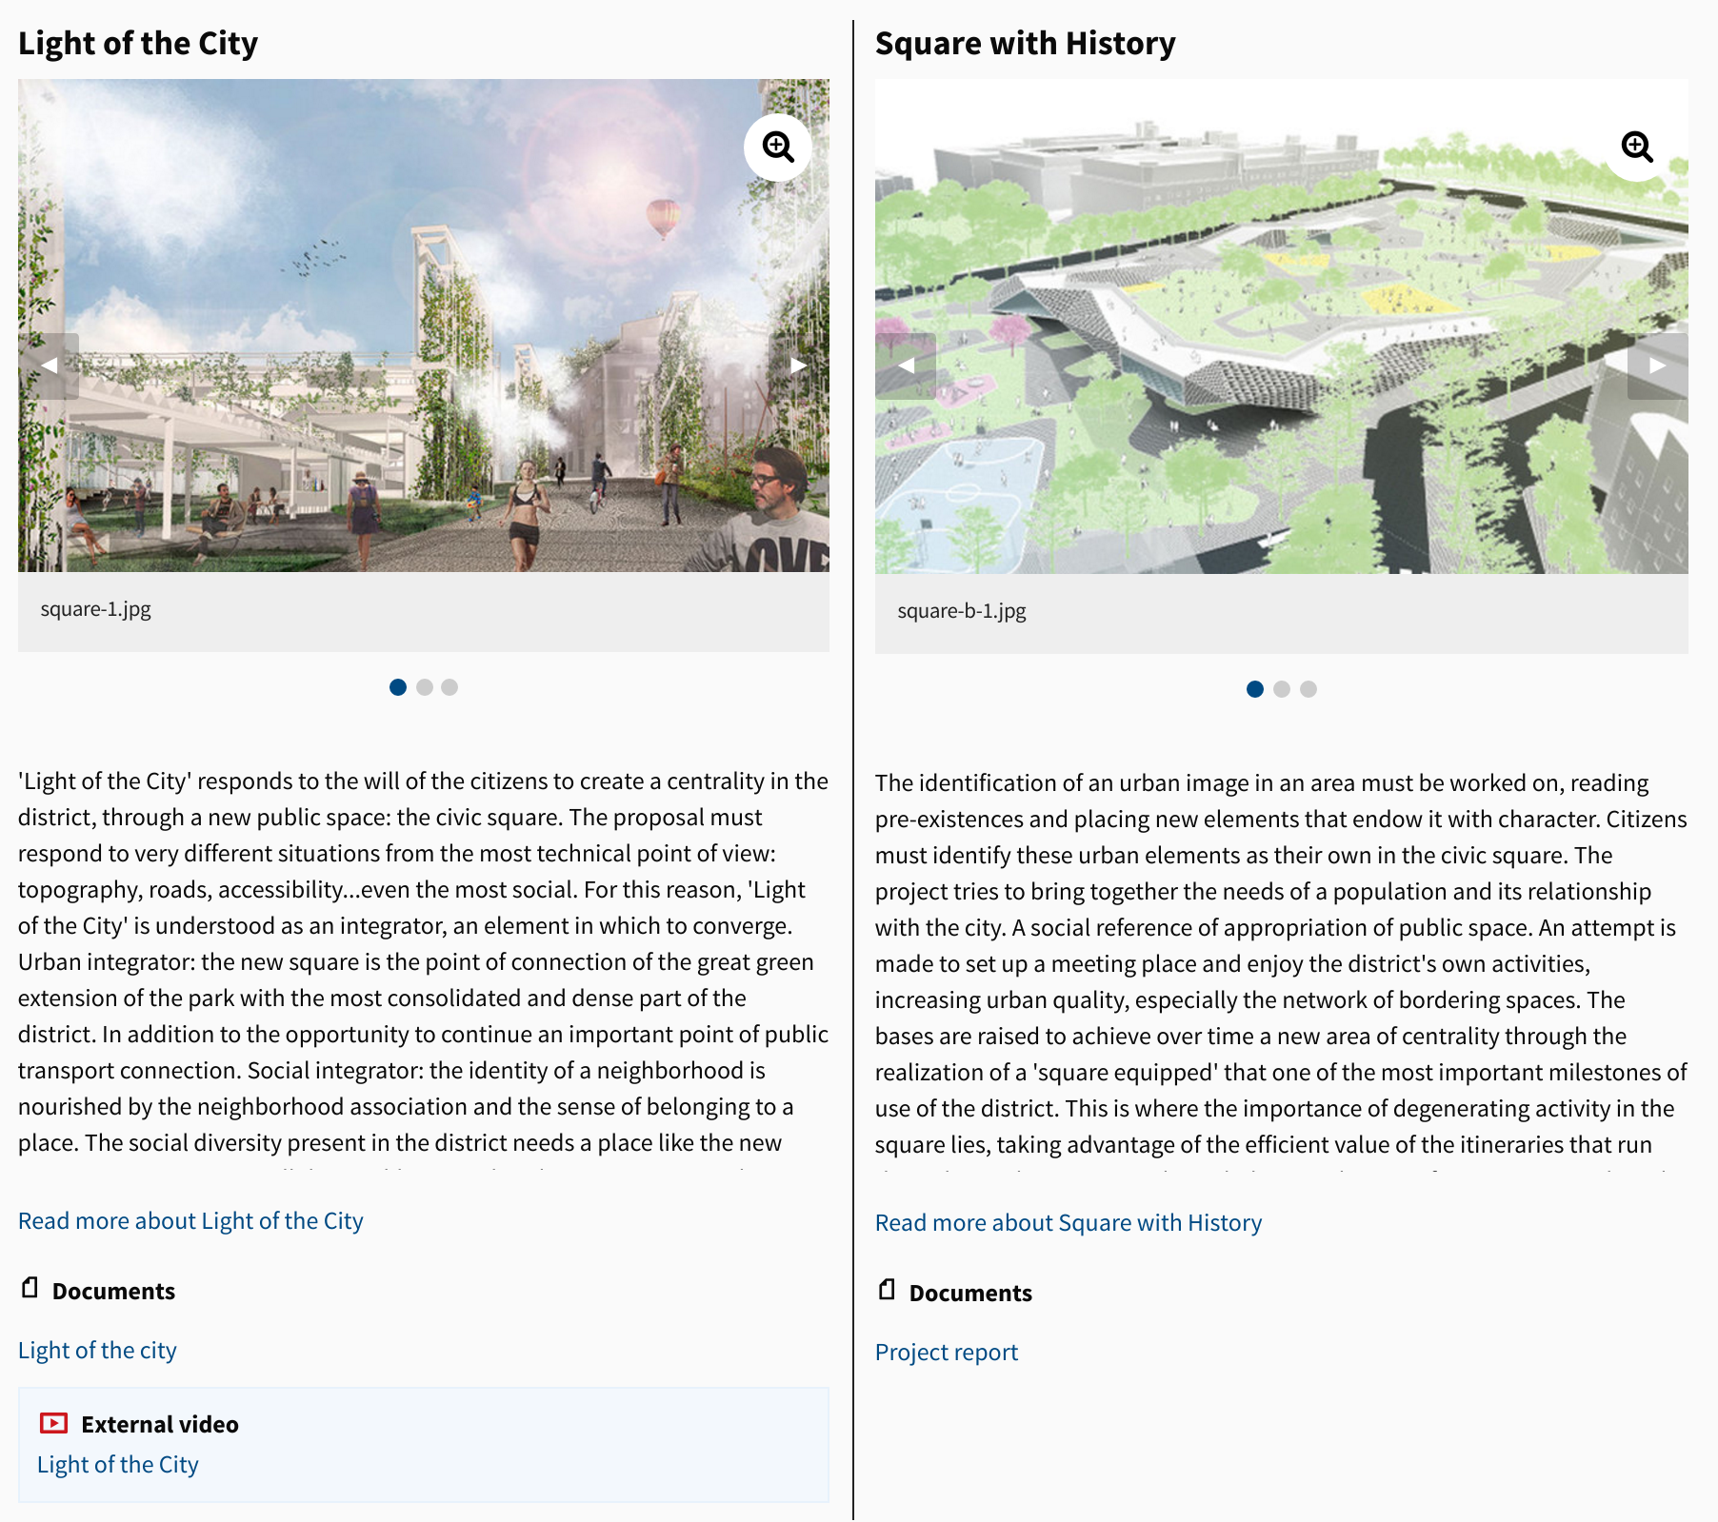

Voting can be configured to involve all users, or only users in certain areas.

3. Collaborative Legislation

A common use of CONSUL is to open legislation, regulations or any type of plan or document to citizen participation.

This is carried out mainly through three phases. These phases can be activated all of them or only some, choosing how to be done independently in each process.

3.1. Preliminary discussion. A first phase of participation may consist of a preliminary discussion. It is common to use this phase when the process begins and no initial text is yet available. It is useful for deciding issues around the main issues to be addressed, and thus steering the process in the most appropriate direction.

At this stage, information is published about the regulation or plan that you want to start dealing with as well as any additional documentation that may be useful.

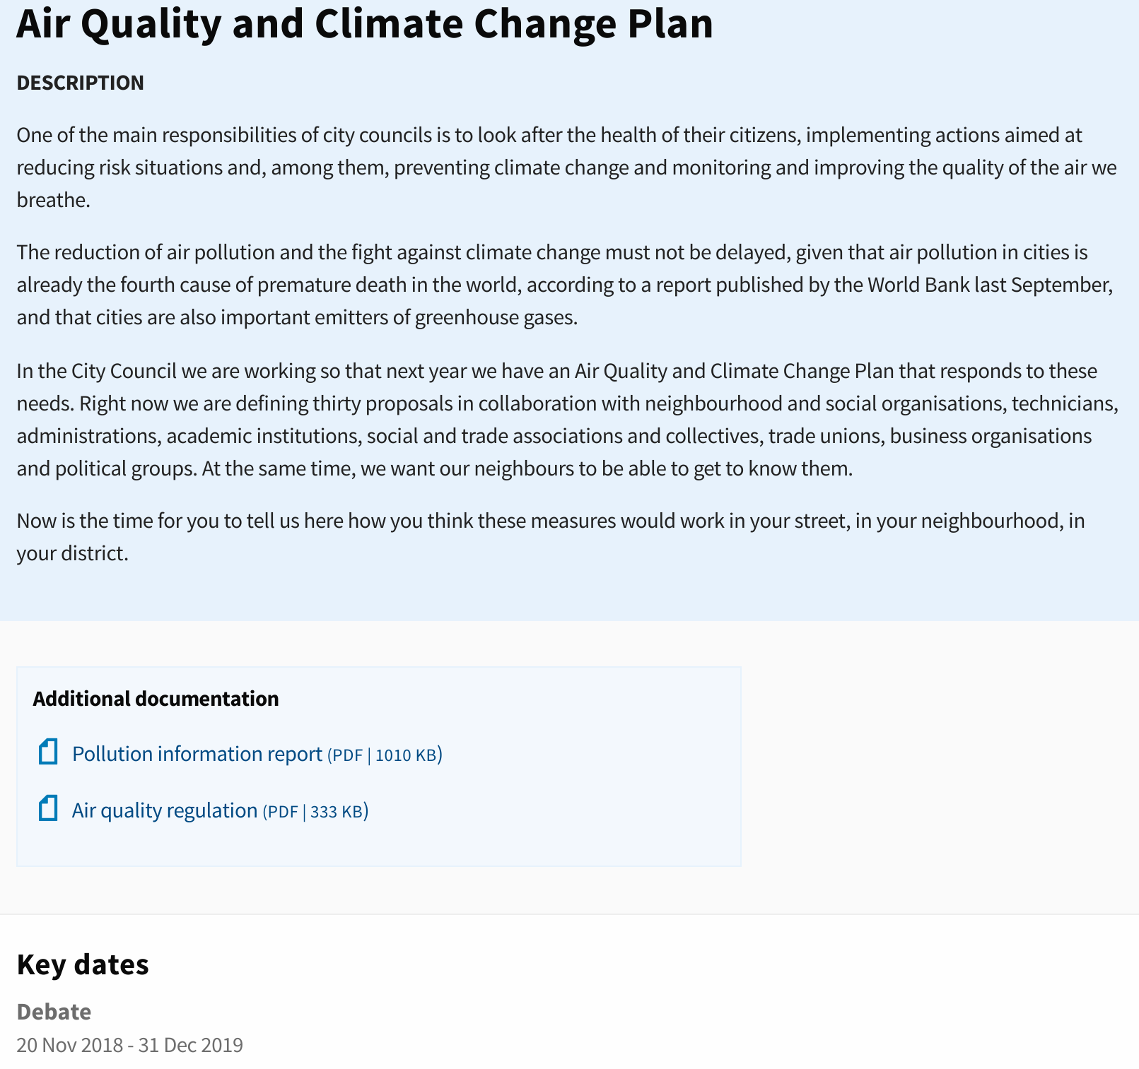Then there are some questions about the main issues of the topic to be addressed, which users will be able to answer openly.

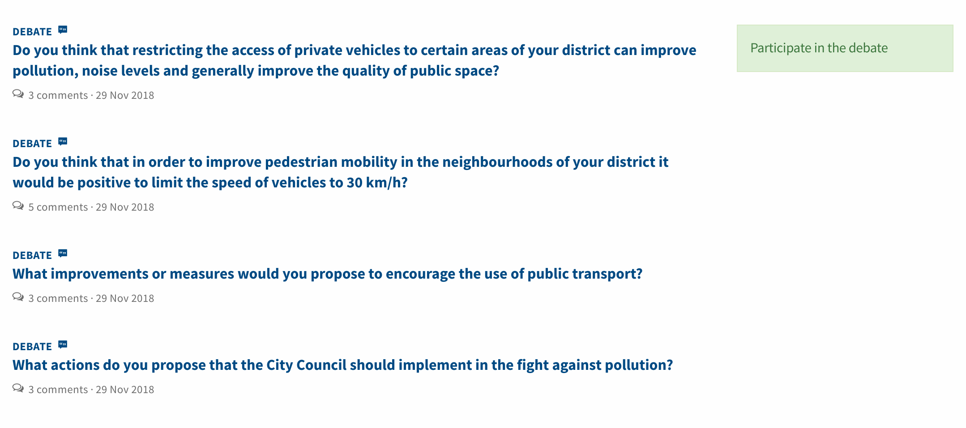

Users can answer the questions, debate with other people and vote on all the answers to identify the most interesting ones.

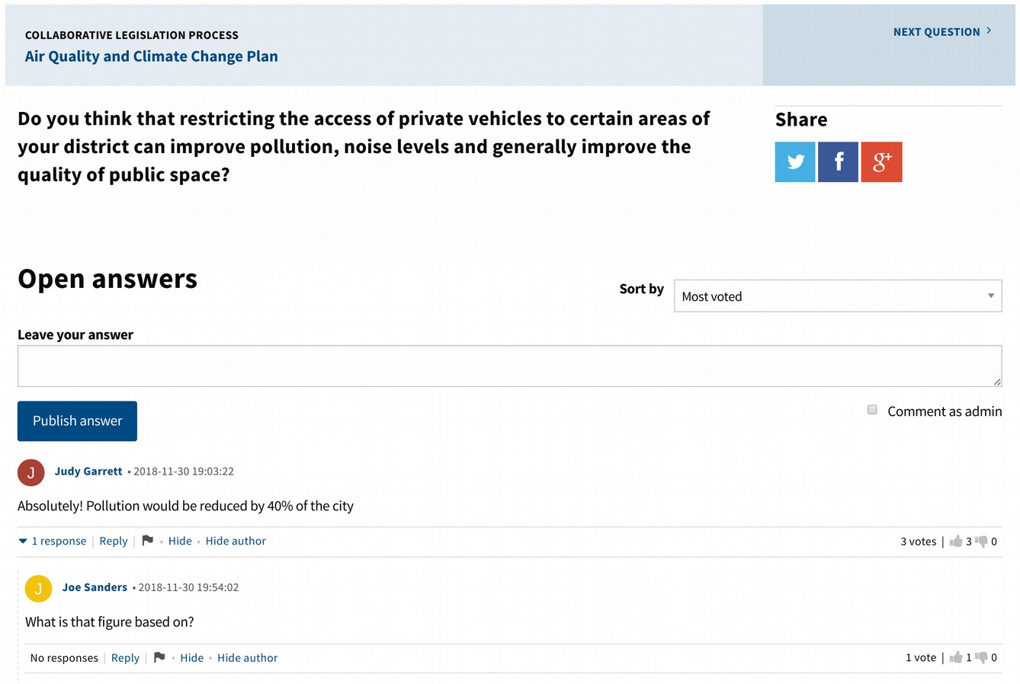

3.2. Proposals. A possible second phase may consist of selecting the best ideas to include in the text. You can publish the ideas that have been worked on from the institution, and also open it up to people to send their ideas. All ideas can be supported, to identify which ones have the greatest approval to be included.

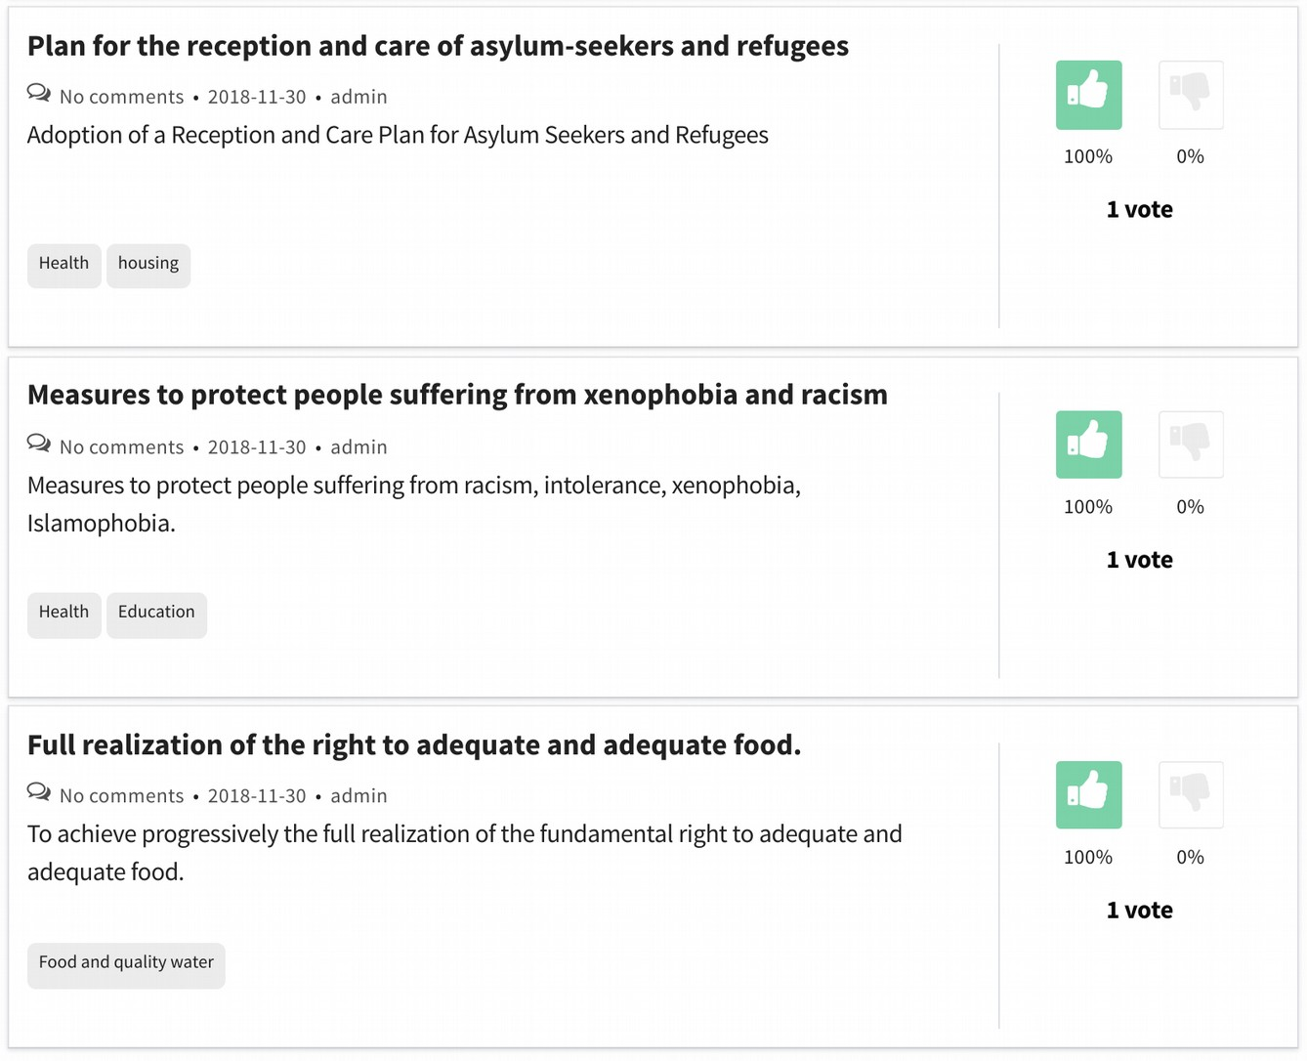

3.3. Comments on texts. This third phase is useful at the end of the process, at a time when there is already a text proposal to open to citizen participation. The platform allows to publish the text and for users to select any part of the text and add a comment to that part.

In addition, comments can be voted, allowing to detect if they have citizen support and which are the most interesting.

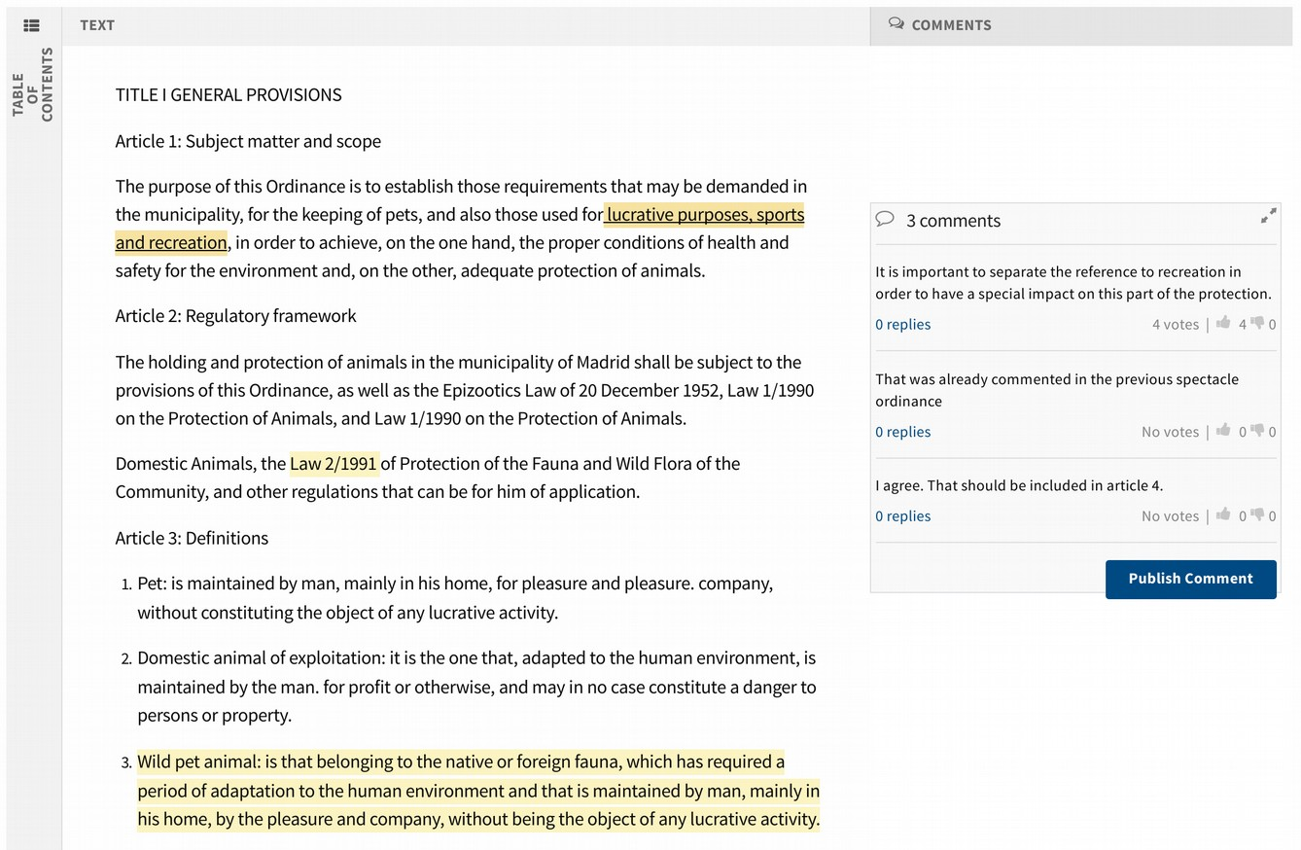

4. Participatory Budgets

The participatory budgeting module allows citizens to directly propose and decide how to spend part of the institution's budget. Each person can make proposals and vote on the initiatives of others. The most voted proposals will be carried out.

The budget can be divided into different categories and groups of categories, and you can choose how you participate in the different categories. For example, in a city you can create two budget groups: one for projects that affect the whole city and another for projects that only affect a specific district. In this case you could configure whether users can vote for projects from all districts or only from one or a limited number of districts.

Another possibility would be to make thematic groups, distributing a part of the budget for a specific theme of budgets: education, health, transparency, etc.

In order to develop participatory budgets, various phases of participation can be activated. It is not necessary to activate all of them, and the parameters of each phase and its duration can be configured as appropriate.

The available phases are as follows: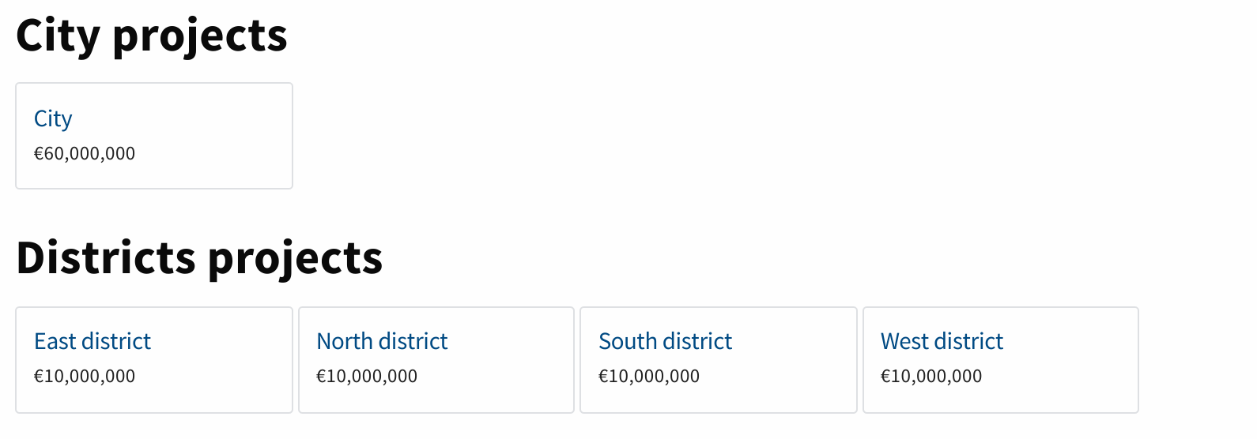

- Presentation of projects. Citizens can submit budget expenditure projects.

- Initial review of projects. During this phase it is no longer possible to submit projects, but they still cannot be supported or voted on. It is a useful phase for all users to see their projects published, and to detect and correct any errors that exist.

- Support phase. This phase allows users to support projects. It is common to receive more projects than what can be evaluated in the next phase, so this phase allows to prioritize which ones should be evaluated because having more support.

- Evaluation of projects. During the evaluation period, projects can be evaluated by the institution. This evaluation makes it possible to mark projects as viable or unfeasible, and in the first case also to assign them a cost. Evaluated viable projects can move on to the voting phase.

- Review of projects. During this phase it is published the selection of projects that pass to the final vote, as well as their cost. That way the users can detect errors in the selection or in the cost.

- Final vote. Users can vote on projects to decide which are the winners.

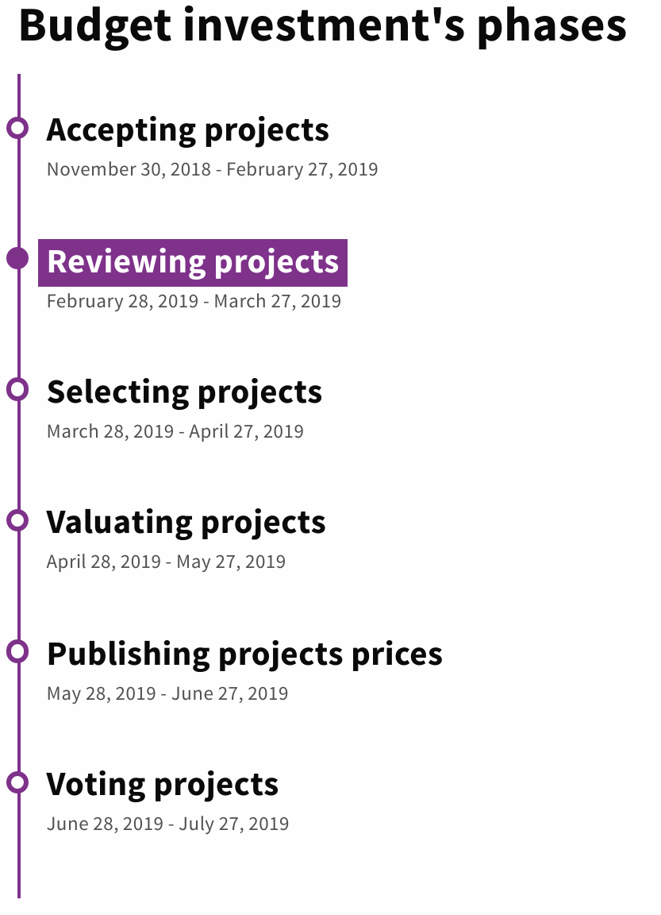

The projects have all the functionalities that are available in the proposals section (see more information in that section): Projects can include tags, images, documentation, videos, location on a map or other relevant information. It also has a comment space, with the possibility for the author to send notifications, with a space for detecting similar projects, and with a community space for users to work together.

The evaluation of projects is done in a decentralized manner. As many evaluators can be registered as needed, and each one will only see in their evaluation interface the projects assigned to them. The administrators of the platform will be able to follow in real time the work of all the evaluators.

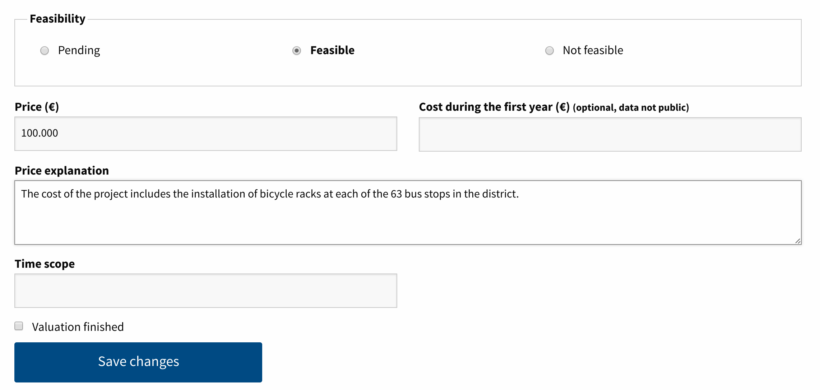

During the final voting phase a "shopping cart" type voting can be used. Each person will have the full budget to spend, and will be able to vote on projects based on their cost until the budget is spent.

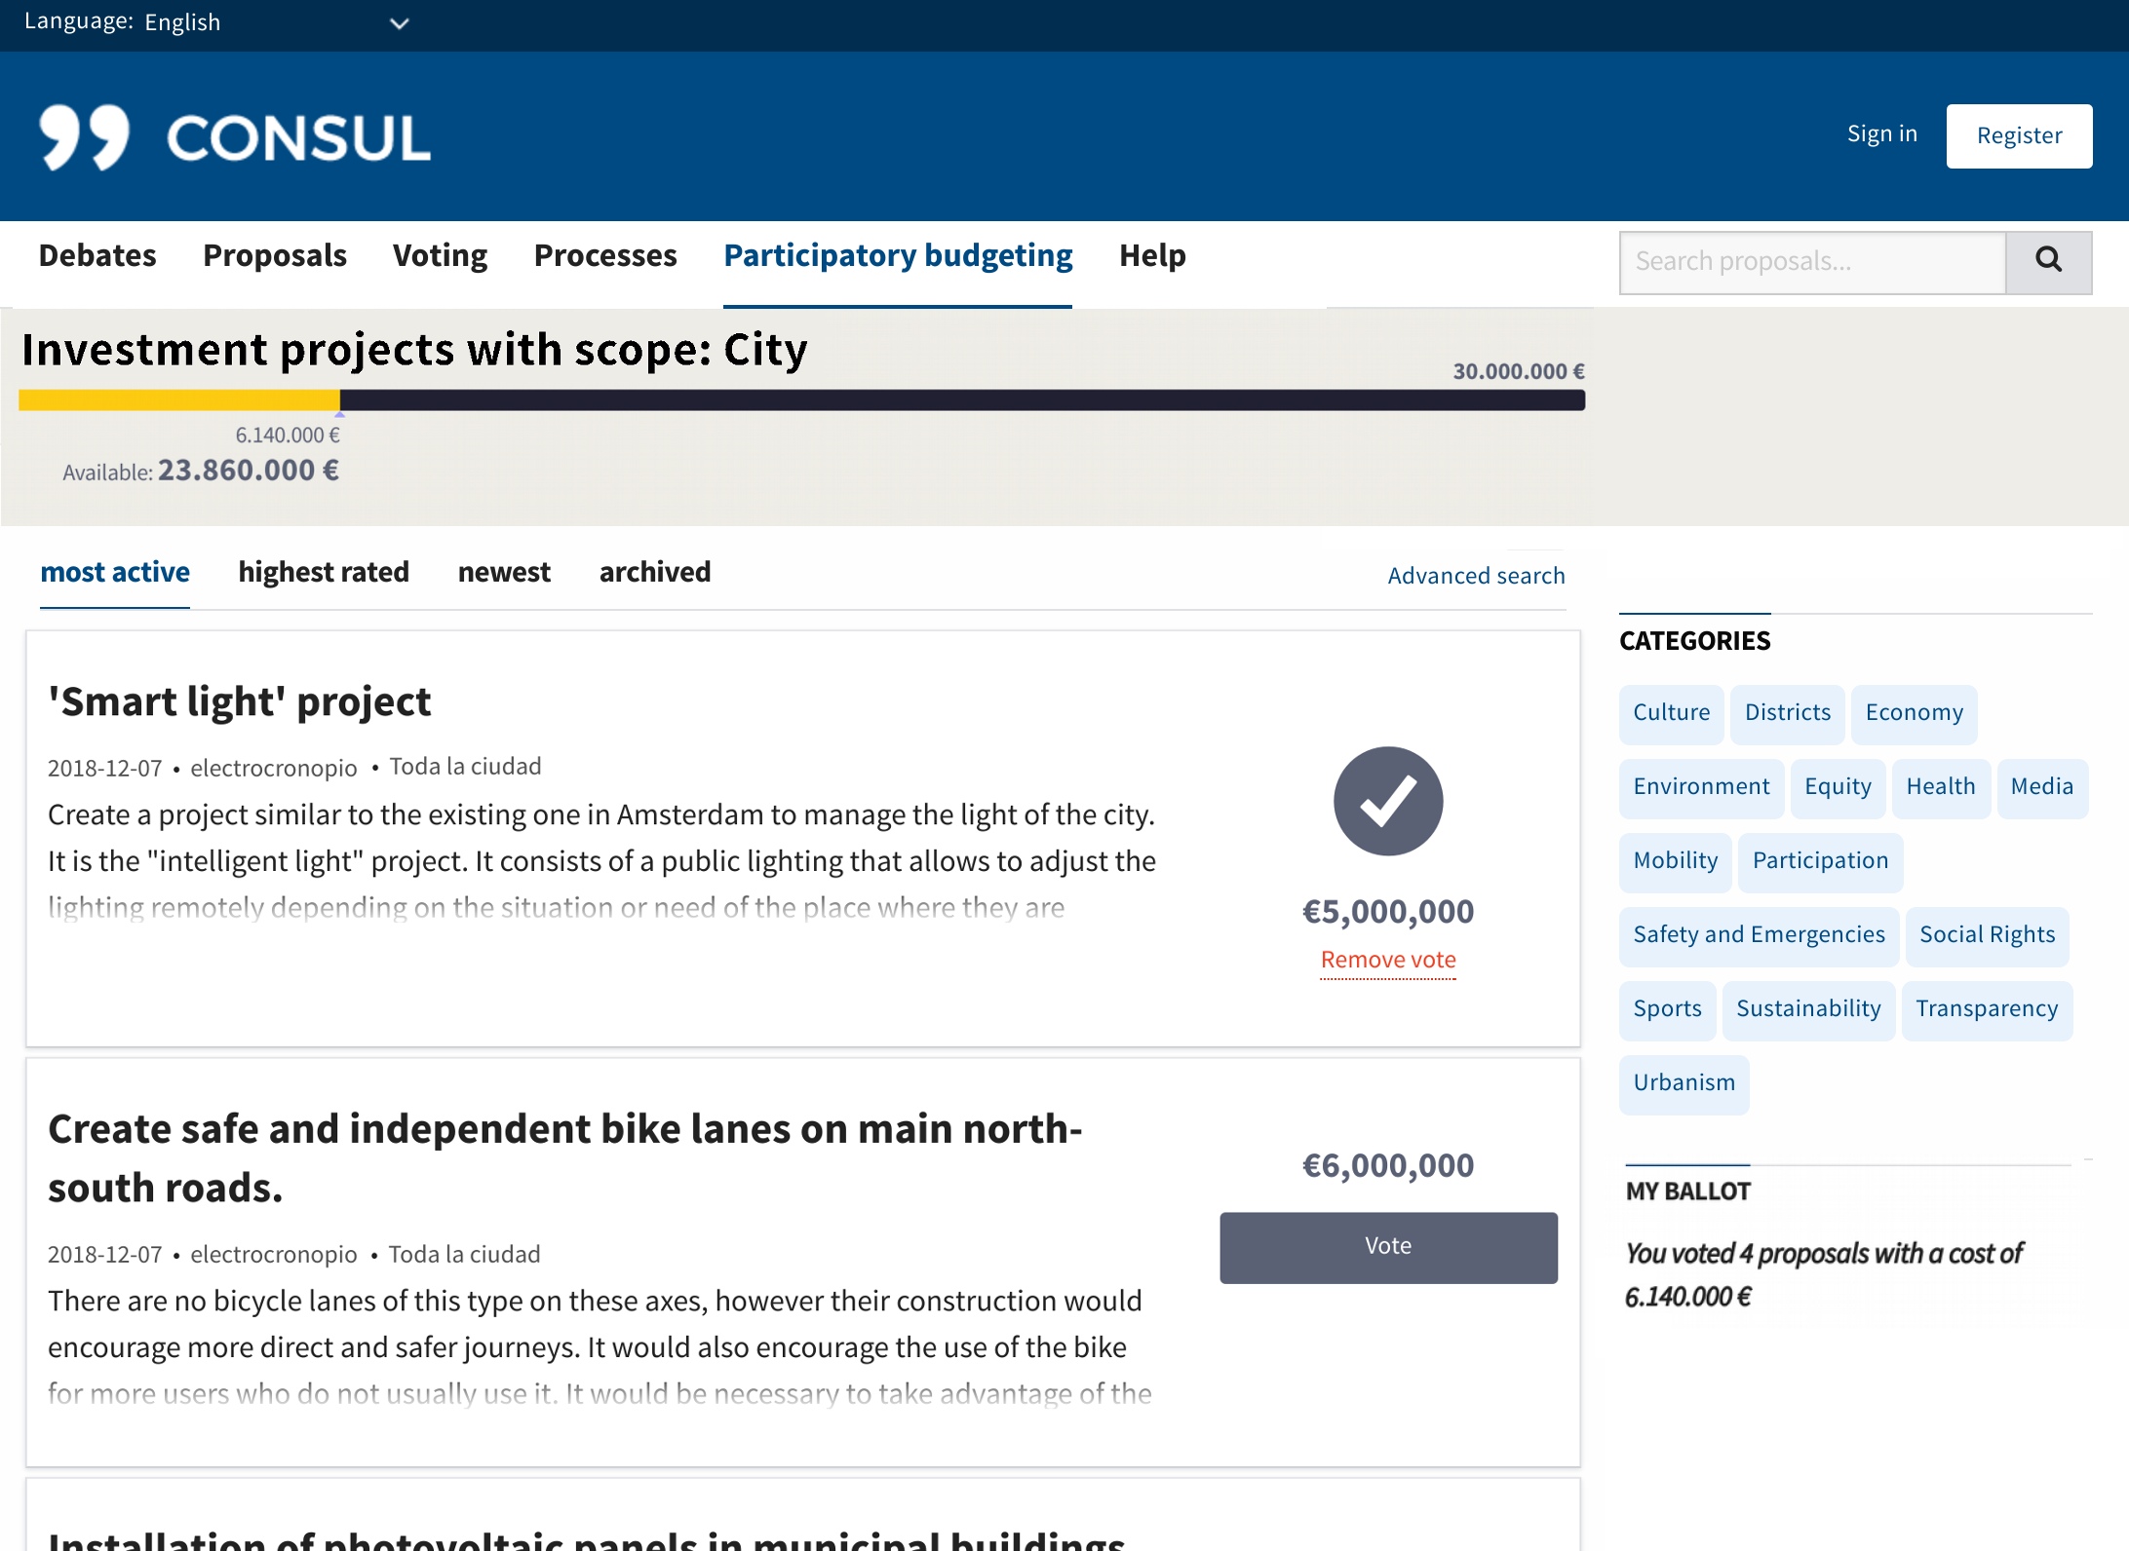

Once the participation process is finished, all the winning projects can be made visible, according to their state of realisation.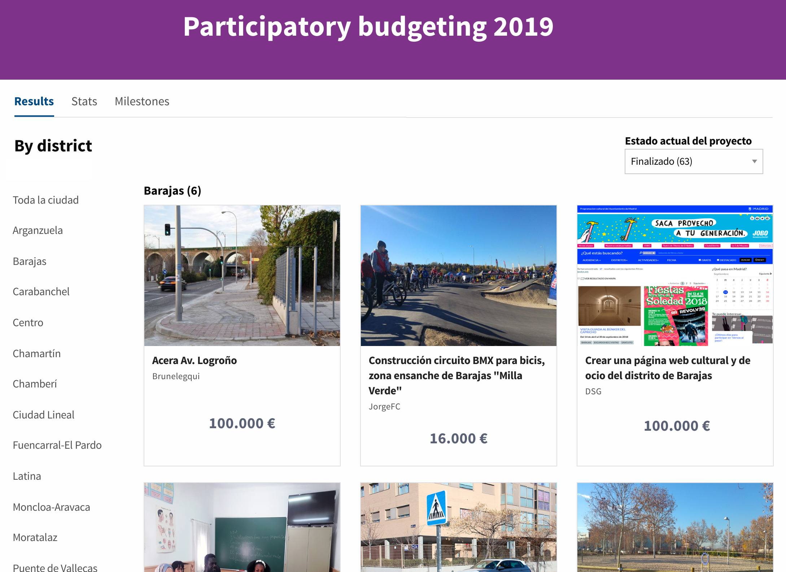

In addition, in each project a timeline is published where any progress made in the realisation of the project can be reported.

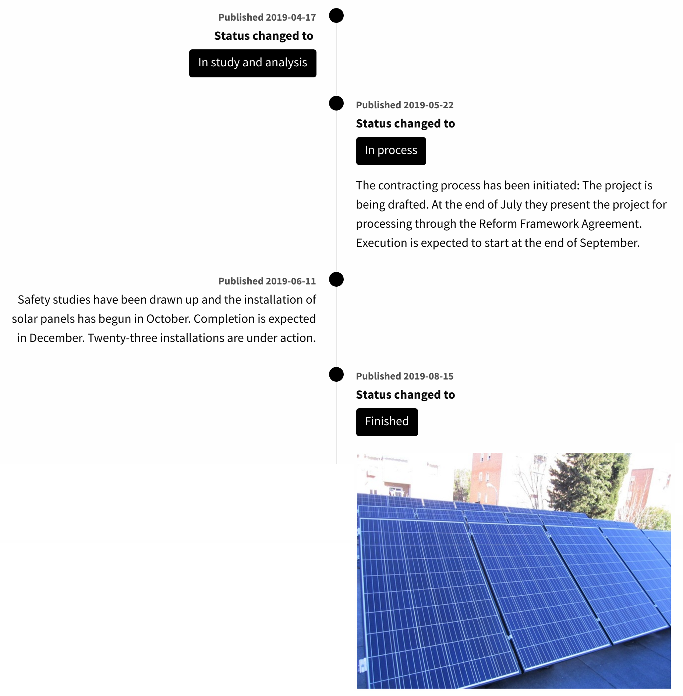

5. Debates

The debates module makes it easier for citizens to make visible the issues that seem important to them, and for them to meet each other to debate or collaborate on these issues. It is a space for listening, but also for citizen gathering.

Users can vote for or against the debates, so that the most highly valued debates are those that are regularly displayed on the main debates page.

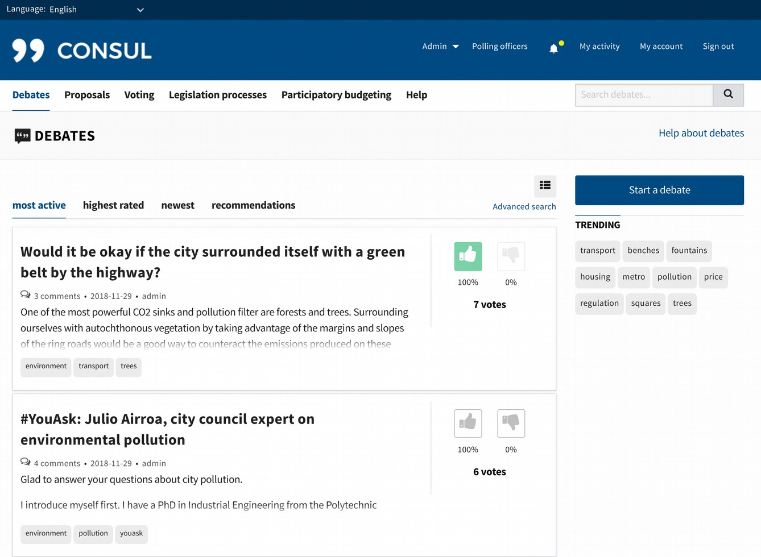

All discussions have a comments section, where users can debate them with each other. Comments are also voted for or against.

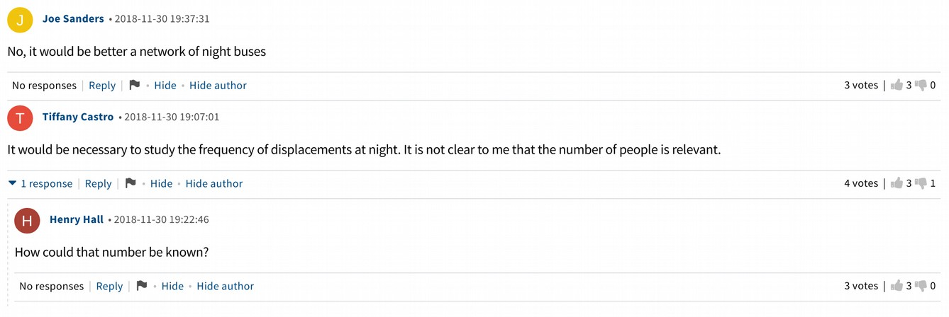

Institutional representatives have verified profiles in order to be able to open the debates they consider appropriate, as well as to respond to any comments. Their interventions are highlighted to give them more visibility.

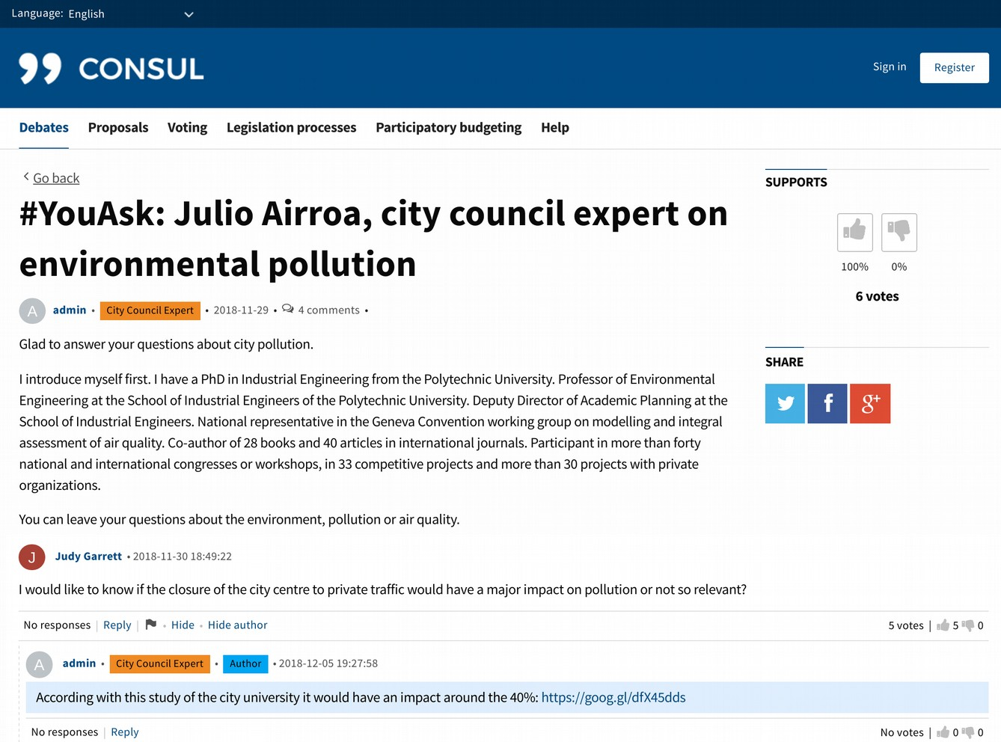

6. Advanced processes

The advanced processes module has been previously shown to be applied to collaborative legislation uses, but it allows other types of uses. The most relevant aspect of this module is the fact of being able to define and combine generic phases of participation in a free way. Thanks to this, it can be adjusted to any new type of participatory process that has not been contemplated before.

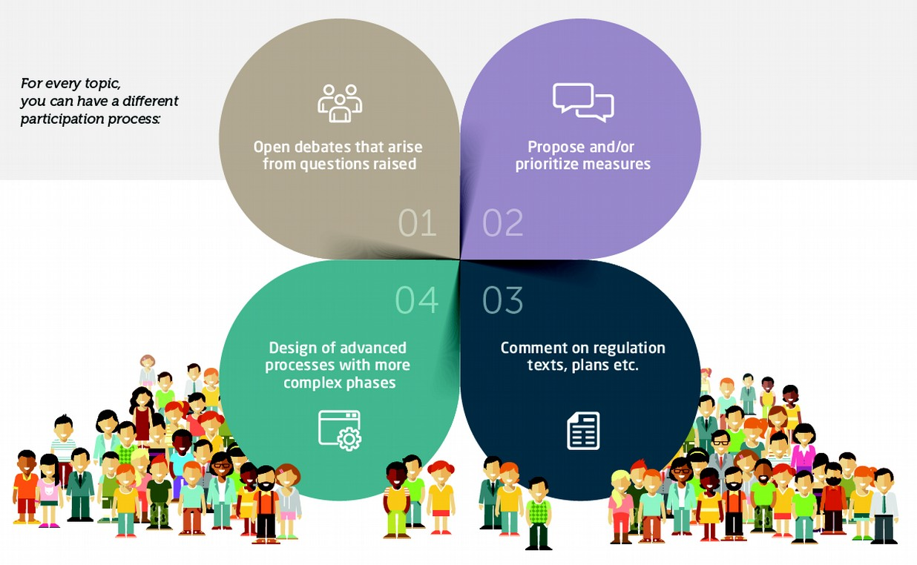

Next we will show some examples of the use of this module.

1. Discussion Phase. The platform allows to open debates on any relevant issue. The users can answer in an open way, dialogue among themselves, and vote the most interesting answers. This allows not only to deal with regulations, but also to deal directly and in a concrete way with any problem or issue that is of special importance.

Unlike the general Debates section of the platform, in this case the debates are not opened by the citizens, but by the institution. Selecting the topics for discussion and the relevant information.

For example here we see an open debate on the situation of a city park:

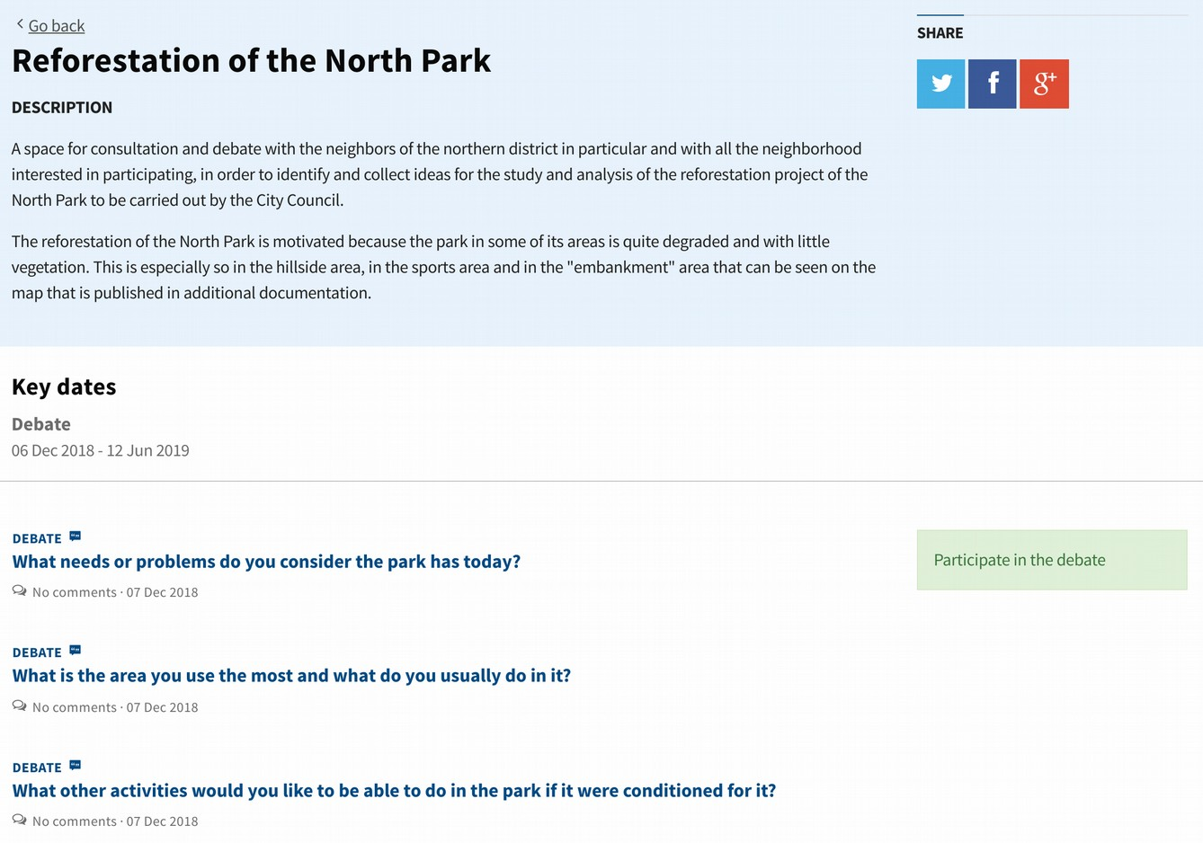

In this case, questions are asked about the situation of the park, its use, activities, etc. In this way, we can easily find out what people think about the subject.

2. Proposals Phase. Another phase of participation, which can be combined with the previous one, or used independently, is the proposals phase. In this case it is not about answering a question, but about proposing ideas on a topic.

Ideas can come from the institution, the users, or both, depending on how the process is configured. All ideas can be supported, in order to detect which ones have more citizen support.

One possible use of this phase that we see below is the Open Plenary. This process consisted of the possibility for citizens to send proposals to the City Council Plenary. The most supported were those selected and their authors were given the opportunity to present their proposals in person at the Plenary, where the spokespersons of the political groups would respond to the proposals.

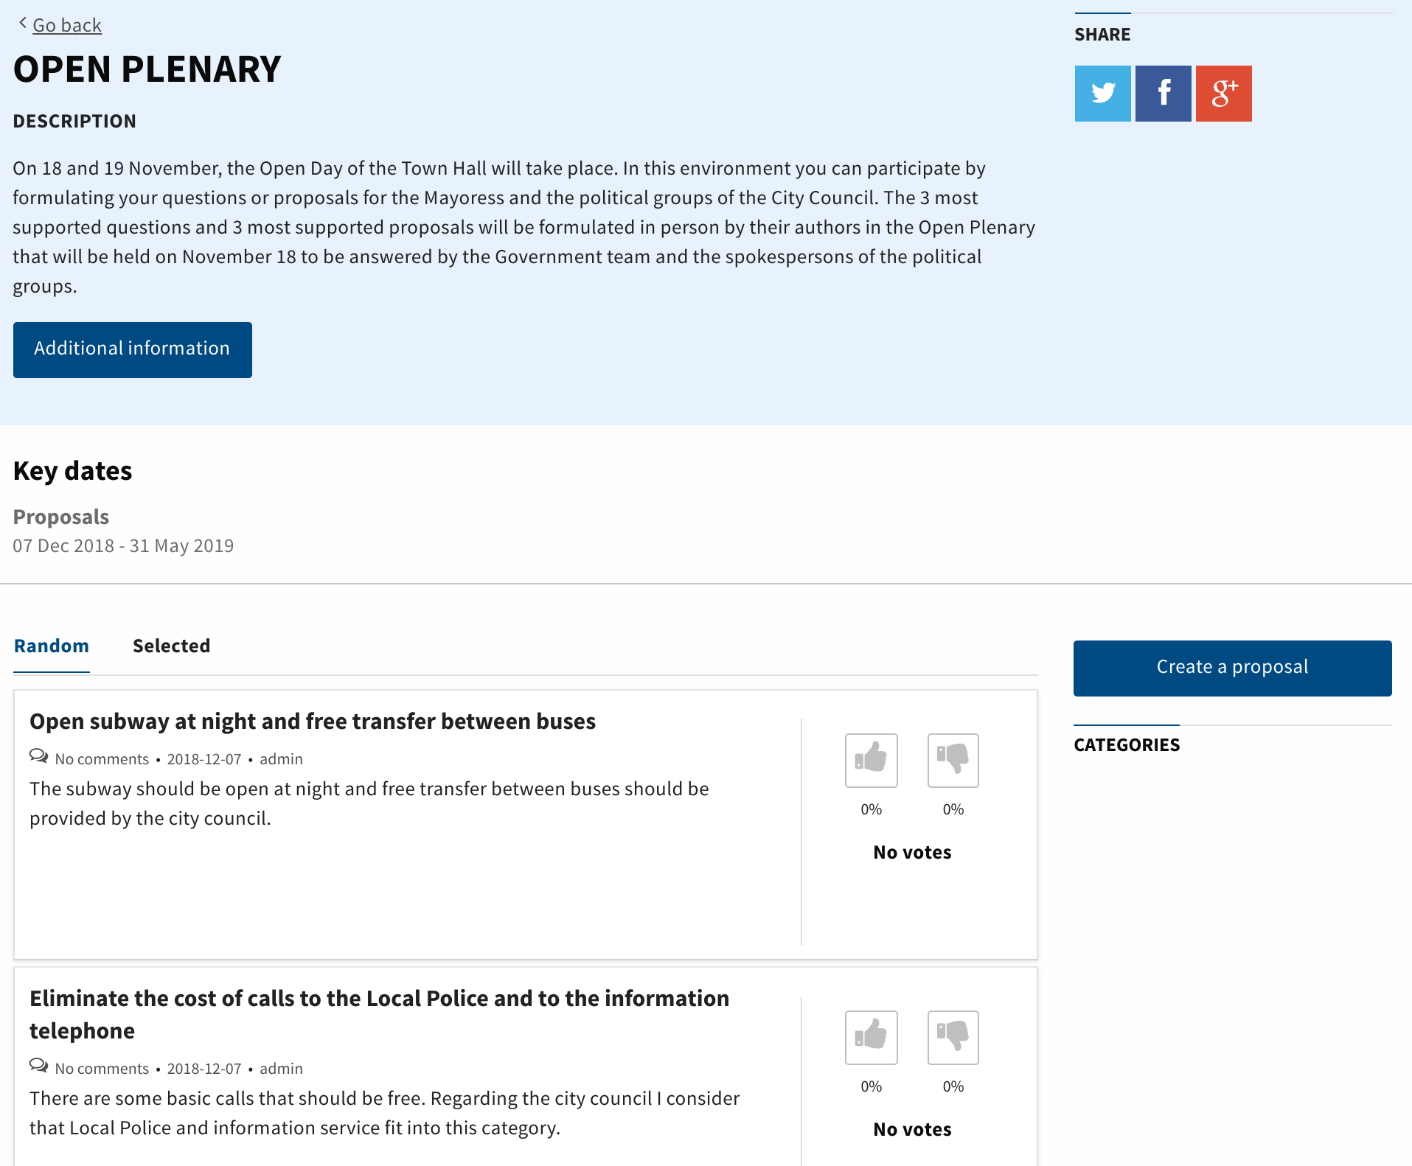

3. Phase of comments of texts. In this phase any text can be open to comments from people. Comments can be voted and answered, generating debates about them.

An interesting use of this phase has been to create a Human Rights Plan at the city level, looking at how to apply Human Rights principles in the local and concrete daily life of a city.

As explained above, the phases of participation can be combined in the same process, with the possibility of starting with a first phase of debate, continuing with the collection of proposals and ending with comments on a text.

The advanced processes module is prepared to include any new phase of participation that has not been considered and that can complement those that currently exist on the platform.

7. Customizable home page

CONSUL has a home page when accessing the platform, which is completely customizable. This page allows us to highlight the most interesting processes, to link graphically to internal or external contents, or to make visible the most supported proposals and debates.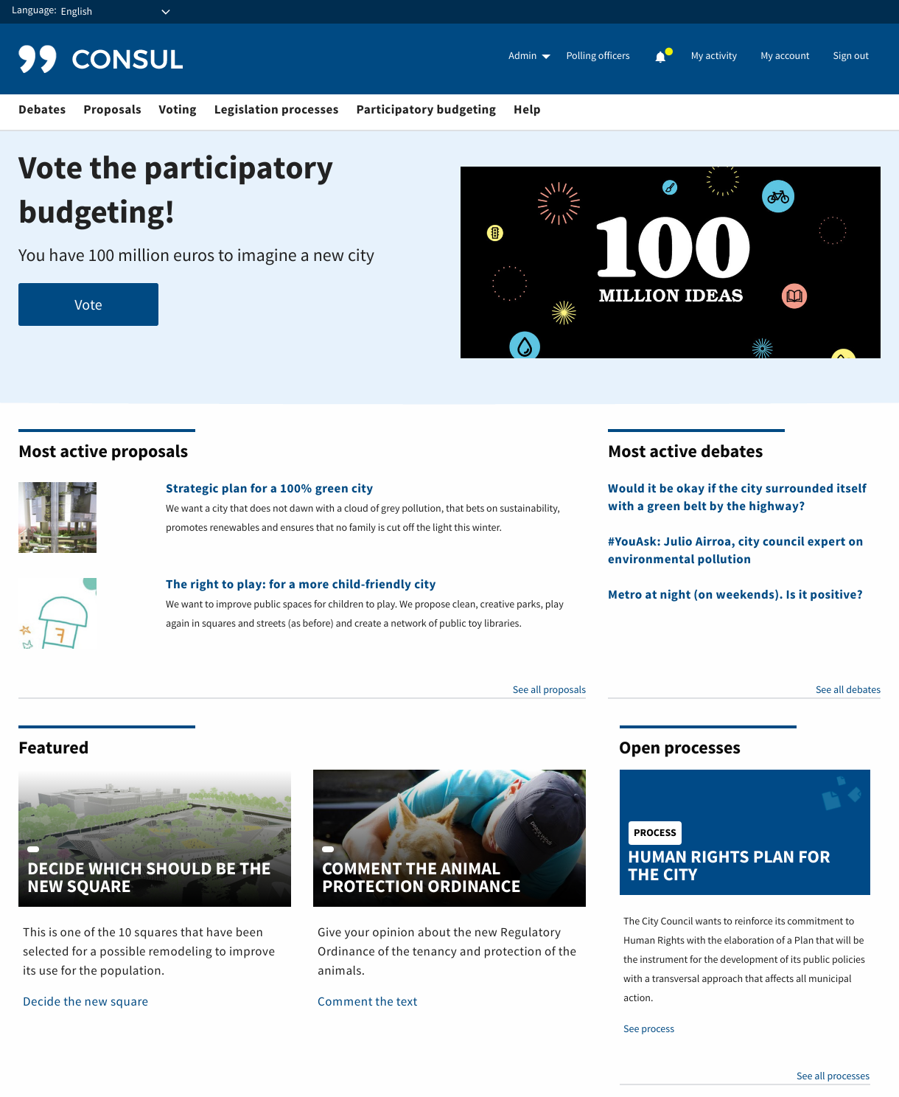

As we can see in the previous example, the initial page is divided into different blocks. All the blocks can be activated or deactivated at any time depending on whether you want to show one information or another.

In the first place we have a block with the initial header, to highlight what seems to us to be the most priority, which will have maximum visibility.

Two other blocks that can be activated are the blocks of Proposals and Active Debates. These blocks automatically show the Proposals and Debates created by the citizens who have the most support.

You can then activate the Process block. This block automatically displays the last open processes.

Finally we find the block of Highlighted Contents. In this block you can create cards on topics that seem important to us to highlight. The title, image, text and link of the card is configurable.

All these blocks are configured and modified in a simple way from the platform administration interface, allowing it to be changed as regularly as needed.

8. Custom Information Pages

CONSUL allows you to create pages with personalized content. These pages can be used for anything related to the platform: information about processes, news, communication campaigns, repository, and so on.

The pages are created from the administration interface in a simple way, using an interface similar to that of a text editing program. Here you can choose the different text formats, including images, links, files, etc.

It also allows you to customize the URLs, so you can use Internet addresses that are easy to remember and access by users.

Here we see an example of one of these custom pages, with some custom text and images:

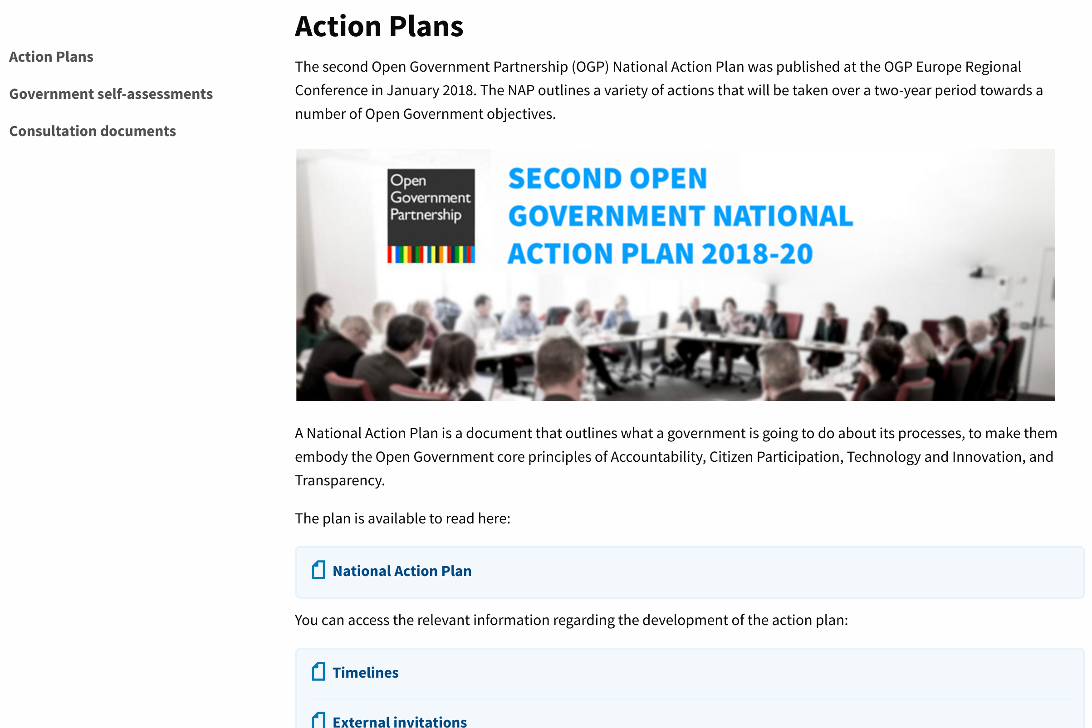

9. Newsletters and notifications

CONSUL has an internal communication system that allows administrators to send e-mails and notifications to users. This system is essential when inviting users to participate in new processes or to communicate the latest news.

Sending can be segmented by users. For example, we could send an email to all users, or only to users whose proposals have won in the participatory budgeting process.

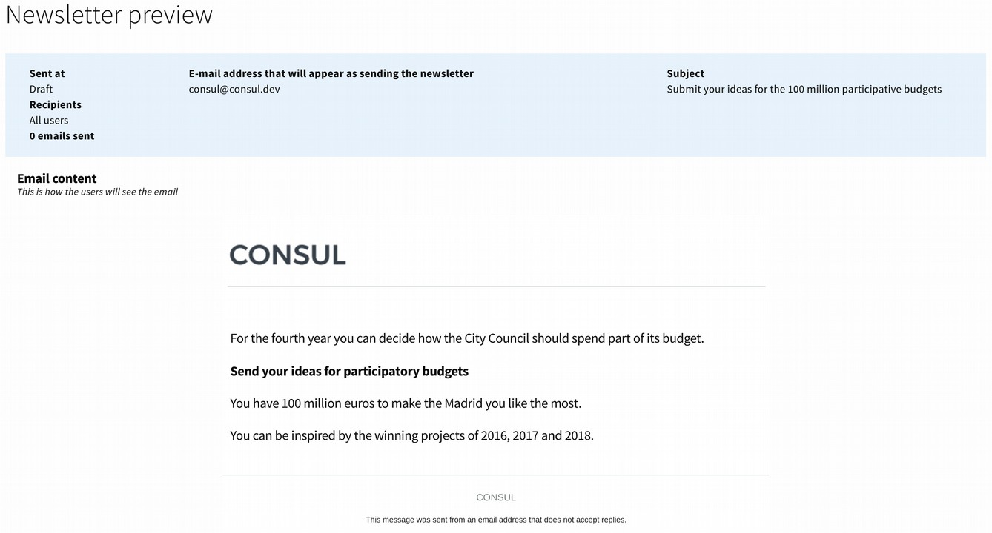

The same possibilities exist for sending internal notifications through the platform.

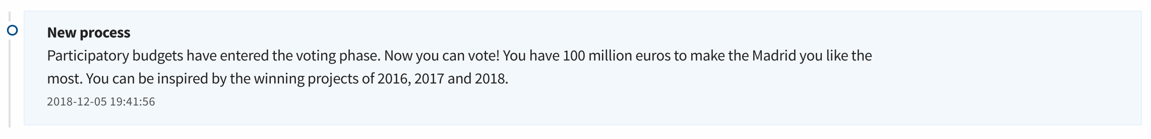

10. Administration, Moderation, Evaluation, Voting and Management Interfaces

CONSUL has a system of user roles, which allows assigning different permissions and functions to each user. The main roles of the platform are administrator, moderator, evaluator, manager and poll officers.

Each of these roles allows access to a special interface, where they have special functionalities:

- Administration Interface. Administrators are the highest level users. They are responsible for managing all the participation processes, as well as the configuration of the platform.

- Moderation Interface. This interface lists all the content of the platform indicated as 'inappropriate' by users. Moderators have the option to hide or confirm the content and block users.

- Evaluation Interface. Evaluators can access this interface to evaluate participatory budget projects. Administrators can assign projects to different evaluators or groups of evaluators. Each evaluator can see only the projects assigned to him in this interface and complete the evaluation report for each project. The evaluation can thus be done in a decentralised way, simplifying the work for each evaluator.

- Management Interface. Managers can create and verify user accounts and perform tasks for users to create or support proposals, etc. The most common destination of this functionality are the public workers of the offices of attention to the citizenship of the institution, to help citizens interact with the process of participation.

- Poll officers Interface. Poll officers can access this interface during a general voting or during the final vote on participatory budgets. This interface is used by those responsible for the face-to-face voting booths, to check that the person who wants to vote can do so, and in case he does so to confirm the vote so that he can not vote a second time at another booth or through the digital platform. It also allows you to enter the results of the vote once it has finished.

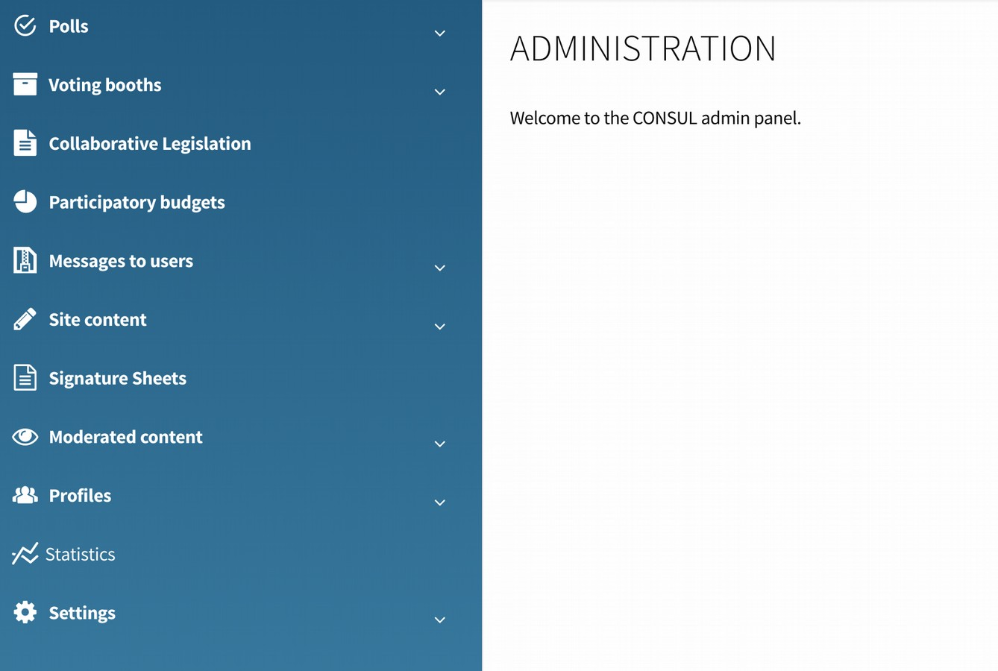

11. Face-to-face participation in the processes

CONSUL allows you to activate face-to-face participation spaces for all the processes that take place on the web. The management of face-to-face spaces is carried out from the web, ensuring that there is coherence between both spaces, and for example no one can vote twice in the same process through the face-to-face space and the web.

Different participation channels can be activated:

- Voting booths. For the general voting and for the voting of participative budgets it is possible to place ballot boxes in the public space. These ballot boxes are monitored in real time from the participation platform, and the participation census is common to the web, in order not to allow double voting.

- Participation through managers. Users marked as managers can perform tasks to help participation, such as creating user accounts, modify their data, or upload proposals or support them on behalf of a user. These managers are usually staff of the institution that help citizens participate. In this way people can participate without having to use a computer.

- Signature sheets. Citizens' proposals and participatory budget projects can collect support on traditional signature sheets. Then these signature sheets can be entered into the platform through the appropriate interface, to count the supports on the web, and discard those that are not valid. Thanks to this, authors of proposals can ask for support for their ideas without the need for a computer.